Supplementary Information

Taxonomic, functional and phylogenetic diversity of ant communities in response to elevational gradients in the Qinling Mountains

Journal name: Biodiversity and Conservation

Mengqin Zhao¹, Khalid A.E. Eisawi¹, Junke Nan², Yuexiang Yang¹, Jingyu Qi¹, Lingxiao Tang¹, Kailang Yang¹*, Hong He¹*

¹Key Laboratory of National Forestry and Grassland Administration for Control of Forest Biological Disasters in Western China, College of Forestry, Northwest A&F University, Yangling, Shaanxi, China
²Key Laboratory of Plant Protection Resources and Pest Management of the Ministry of Education, College of Plant Protection, Northwest A&F University, Yangling, Shaanxi, China

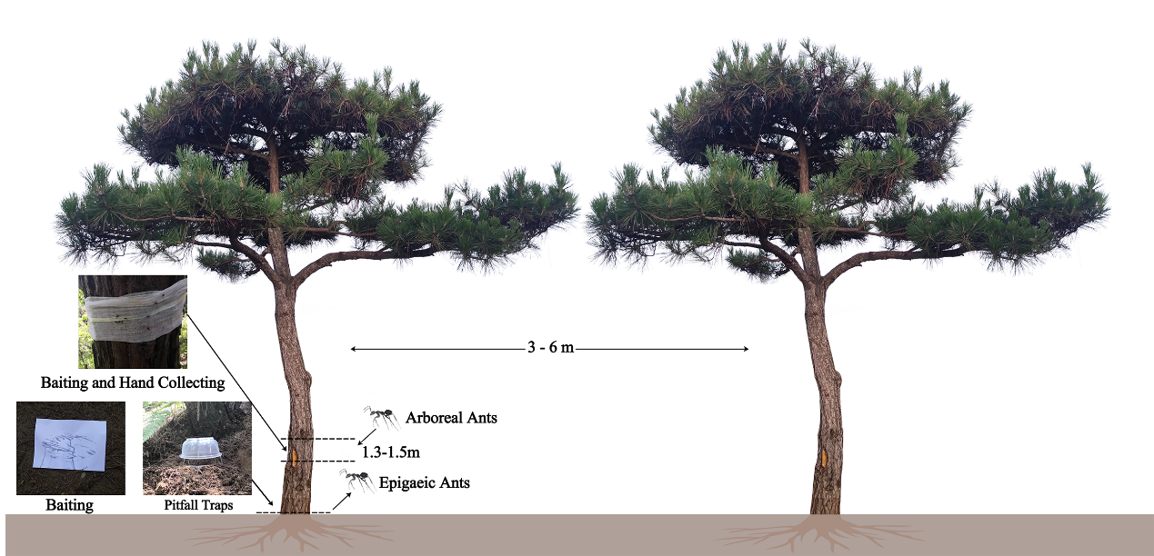
Fig. S1 The demonstration of sampling arboreal and epigaeic ants in this study.

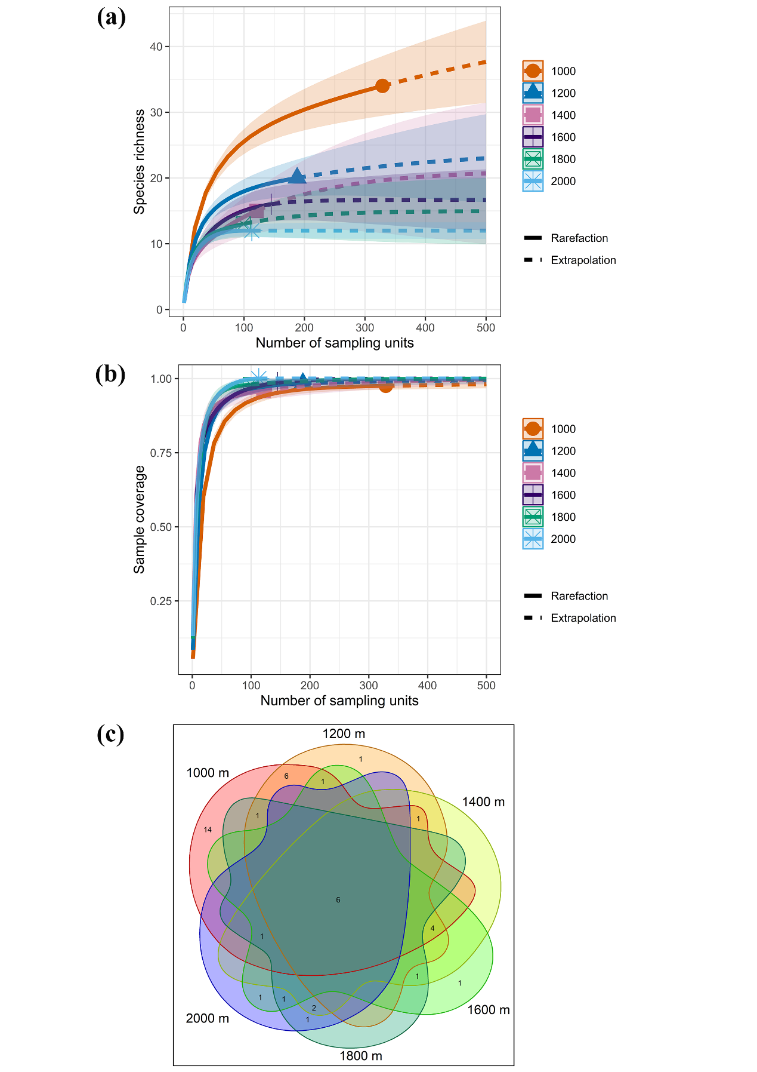
Fig. S2 (a) Species richness and (b) sample coverage of rarefaction and extrapolation (dotted line) curves with 95% confidence intervals (shaded areas) along different elevations; (c) Venn diagram illustrating the number of shared and unique ant species of each site along different elevations.
Table S1 Sampling design description
Elevational band | Site | Plot | Elevation | Main tree species
1000 m.a.s.l | ES1 | EP1 | 967 m.a.s.l |  | Pinus tabuliformis, Quercus sp.
1000 m.a.s.l | ES1 | EP2 | 1019 m.a.s.l |  | Pinus massoniana, P. tabuliformis, Q. sp.
1000 m.a.s.l | ES1 | EP3 | 1046 m.a.s.l |  | P. tabuliformis, Q. sp.
1200 m.a.s.l | ES2 | EP4 | 1198 m.a.s.l |  | P. tabuliformis, Pinus armandii, Q. sp.
1200 m.a.s.l | ES2 | EP5 | 1256 m.a.s.l |  | P. tabuliformis, Q. sp.
1200 m.a.s.l | ES2 | EP6 | 1298 m.a.s.l |  | P. tabuliformis, P. armandii, Q. sp.
1400 m.a.s.l | ES3 | EP7 | 1448 m.a.s.l |  | P. tabuliformis, P. armandii
1400 m.a.s.l | ES3 | EP8 | 1462 m.a.s.l |  | P. tabuliformis, Q. sp.
1400 m.a.s.l | ES3 | EP9 | 1480 m.a.s.l |  | P. tabuliformis
1600 m.a.s.l | ES4 | EP10 | 1616 m.a.s.l |  | P. tabuliformis
1600 m.a.s.l | ES4 | EP11 | 1635 m.a.s.l |  | P. tabuliformis, P. armandii
1600 m.a.s.l | ES4 | EP12 | 1643 m.a.s.l |  | P. tabuliformis, P. armandii
1800 m.a.s.l | ES5 | EP13 | 1754 m.a.s.l |  | P. tabuliformis
1800 m.a.s.l | ES5 | EP14 | 1803 m.a.s.l |  | P. tabuliformis
1800 m.a.s.l | ES5 | EP15 | 1843 m.a.s.l |  | P. tabuliformis
2000 m.a.s.l | ES6 | EP16 | 1915 m.a.s.l |  | P. tabuliformis, Betula albosinensis
2000 m.a.s.l | ES6 | EP17 | 1997 m.a.s.l |  | P. tabuliformis, Abies sp., Picea sp.
2000 m.a.s.l | ES6 | EP18 | 2029 m.a.s.l |  | P. armandii, A. sp., P. sp.
Note: m.a.s.l represents meters above sea level.
Table S2 The information of collected samples: ant species, the numbers of workers at each site and the relative abundance of each species
Subfamily | Ant species | Relative abundance  (%) | Worker number at each site
Subfamily | Ant species | Relative abundance  (%) | ES1  (1000 m) | ES2  (1200 m) | ES3  (1400 m) | ES4  (1600 m) | ES5  (1800 m) | ES6  (2000 m)
Dolichoderinae | Dolichoderus sibiricus (Emery, 1889) | 0.42 | 45 | 3 | 0 | 0 | 0 | 0
Dolichoderinae | Liometopum sinense (Wheeler, 1921) | 2.77 | 314 | 0 | 0 | 0 | 0 | 0
Dolichoderinae | Tapinoma geei (Wheeler, 1927) | 0.84 | 63 | 32 | 0 | 0 | 0 | 0
Dolichoderinae | Tapinoma indicum (Forel, 1895) | 0.43 | 33 | 16 | 0 | 0 | 0 | 0
Formicinae | Camponotus herculeanus (Linnaeus, 1758) | 0.03 | 0 | 0 | 0 | 3 | 0 | 0
Formicinae | Camponotus japonicus (Mayr, 1866) | 0.04 | 5 | 0 | 0 | 0 | 0 | 0
Formicinae | Camponotus mitis (Smith, 1858) | 0.21 | 10 | 6 | 8 | 0 | 0 | 0
Formicinae | Camponotus sp. (Mayr, 1861) | 0.02 | 2 | 0 | 0 | 0 | 0 | 0
Formicinae | Formica fusca (Linnaeus, 1758) | 0.33 | 0 | 0 | 12 | 0 | 13 | 13
Formicinae | Formica japonica (Motschoulsky, 1866) | 8.84 | 900 | 84 | 0 | 0 | 19 | 0
Formicinae | Lasius alienus (Foerster, 1850) | 9.72 | 859 | 106 | 1 | 35 | 57 | 45
Formicinae | Lasius flavus (Fabricius, 1782) | 0.24 | 4 | 1 | 1 | 21 | 0 | 0
Formicinae | Lasius fuliginosus (Latreille, 1798) | 8.48 | 110 | 832 | 0 | 20 | 0 | 0
Formicinae | Nylanderia pieli (Santschi, 1928) | 0.47 | 16 | 30 | 3 | 4 | 0 | 0
Formicinae | Nylanderia sharpii (Forel, 1899) | 20.70 | 602 | 518 | 554 | 642 | 30 | 3
Formicinae | Nylanderia sp. (Emery, 1906) | 1.54 | 0 | 175 | 0 | 0 | 0 | 0
Formicinae | Polyrhachis lamellidens (Smith, 1874) | 2.49 | 283 | 0 | 0 | 0 | 0 | 0
Formicinae | Polyergus samurai (Yano, 1911) | 0.59 | 67 | 0 | 0 | 0 | 0 | 0
Formicinae | Prenolepis angularis (Zhou, 2001) | 2.57 | 0 | 0 | 20 | 271 | 1 | 0
Myrmicinae | Aphaenogaster caeciliae (Viehmeyer, 1922) | 7.63 | 166 | 444 | 75 | 146 | 23 | 12
Myrmicinae | Crematogaster anthracina (Smith, 1857) | 10.57 | 1198 | 1 | 0 | 0 | 0 | 0
Myrmicinae | Crematogaster osakensis (Forel, 1900) | 0.56 | 63 | 0 | 0 | 0 | 0 | 0
Myrmicinae | Lordomyrma bhutanensis (Baroni Urbani, 1977) | 0.94 | 83 | 0 | 3 | 13 | 4 | 4
Myrmicinae | Myrmecina pauca (Huang et al., 2008) | 0.02 | 2 | 0 | 0 | 0 | 0 | 0
Myrmicinae | Myrmica luteola (Kupyanskaya, 1990) | 0.12 | 0 | 0 | 0 | 1 | 0 | 13
Myrmicinae | Myrmica mifui (Chen et al., 2016) | 0.78 | 0 | 0 | 0 | 3 | 14 | 72
Myrmicinae | Myrmica sp. (Latreille, 1804) | 4.63 | 11 | 16 | 174 | 181 | 110 | 33
Myrmicinae | Myrmica taibaiensis (Wei et al., 2001) | 3.00 | 0 | 0 | 0 | 0 | 35 | 305
Myrmicinae | Perissomyrmex bidentatus (Zhou & Huang, 2006) | 0.04 | 0 | 0 | 1 | 0 | 1 | 3
Myrmicinae | Pheidole fervida (Smith, 1874) | 6.41 | 583 | 35 | 88 | 15 | 2 | 4
Myrmicinae | Pristomyrmex punctatus (Smith, 1860) | 1.12 | 127 | 0 | 0 | 0 | 0 | 0
Myrmicinae | Strumigenys lewisi (Cameron, 1886) | 0.04 | 4 | 0 | 0 | 0 | 0 | 0
Myrmicinae | Syllophopsis sp. (Santschi, 1915) | 0.02 | 1 | 1 | 0 | 0 | 0 | 0
Myrmicinae | Temnothorax argentipes (Wheeler, 1928) | 0.07 | 8 | 0 | 0 | 0 | 0 | 0
Myrmicinae | Temnothorax shannxiensis (Zhou et al., 2010) | 0.95 | 1 | 45 | 28 | 11 | 9 | 14
Myrmicinae | Tetramorium smithi (Mayr, 1879) | 0.60 | 68 | 0 | 0 | 0 | 0 | 0
Ponerinae | Brachyponera chinensis (Emery, 1895) | 0.01 | 1 | 0 | 0 | 0 | 0 | 0
Ponerinae | Ectomomyrmex javanus (Mayr, 1867) | 1.24 | 123 | 18 | 0 | 0 | 0 | 0
Ponerinae | Hypoponera beppin (Terayama, 1999) | 0.36 | 1 | 23 | 16 | 1 | 0 | 0
Ponerinae | Hypoponera sauteri (Wheeler, 1929) | 0.02 | 2 | 0 | 0 | 0 | 0 | 0
Ponerinae | Odontomachus monticola (Emery, 1892) | 0.01 | 1 | 0 | 0 | 0 | 0 | 0
Ponerinae | Ponera paedericera (Zhou, 2001) | 0.13 | 7 | 5 | 1 | 2 | 0 | 0
Note: The relative abundance of each species = (Worker number of each ant species / total worker number of all ant species) ×100%
Table S3 The six functional traits measured, their measurement and functional significance
Functional trait | Trait measurement | Functional significance
Weber’s length | The maximum length from the anterior edge of the pronotum to the posterior edge of the propodeum | It is the indicator of whole-body size, which is associated with foraging preference and defense strategies (Weiser & Kaspari, 2006).
Head width | In full face view across the eyes | Size of interstices through which ants can pass (Sarty et al., 2006); mandibular musculature (Kaspari, 1993).
Scape length | Collar to antennal elbow | It limits the distance ahead of the ant that it receives chemosensory information, for example pheromone trails (Yates et al., 2014).
Eye length | The maximum length of the eye | As an indicator of habitat use and foraging efficiency, eye length is related to vision location and food searching (Keller, 2011; Gibb et al., 2015).
Mandible length | From mandibular insertion to most distal point | It is related to the type of food resources consumed by ants (Weiser & Kaspari, 2006).
Hind leg length | The sum of hind femur length and hind tibia length | Longer legged ant species are characterized by efficient locomotion and foraging (Gibb & Parr, 2013).

Table S4 The data of six functional traits of all ant species
Subfamily | Species | Functional traits (mm)
Subfamily | Species | Weber’s length | Head width | Scape length | Eye length | Mandible length | Hind leg length
Dolichoderinae | D. sibiricus | 1.160 ± 0.054 | 0.801 ± 0.042 | 0.710 ± 0.048 | 0.202 ± 0.013 | 0.426 ± 0.034 | 1.438 ± 0.077
Dolichoderinae | L. sinense | 1.821 ± 0.243 | 1.343 ± 0.177 | 1.073 ± 0.184 | 0.245 ± 0.027 | 0.679 ± 0.131 | 2.572 ± 0.300
Dolichoderinae | T. geei | 0.791 | 0.610 | 0.682 | 0.183 | 0.390 | 1.255
Dolichoderinae | T. indicum | 0.490 ± 0.013 | 0.370 ± 0.004 | 0.380 ± 0.014 | 0.096 ± 0.006 | 0.204 ± 0.004 | 0.704 ± 0.006
Formicinae | C. herculeanus | 3.387 | 2.653 | 2.162 | 0.566 | 1.231 | 5.509
Formicinae | C. japonicus | 2.837 ± 0.129 | 1.455 ± 0.163 | 1.906 ± 0.094 | 0.412 ± 0.048 | 0.887 ± 0.068 | 4.399 ± 0.313
Formicinae | C. mitis | 2.955 ± 0.220 | 1.501 ± 0.189 | 1.938 ± 0.055 | 0.461 ± 0.023 | 0.857 ± 0.032 | 5.169 ± 0.960
Formicinae | C. sp. | 1.668 | 1.092 | 1.173 | 0.269 | 0.534 | 2.445
Formicinae | F. fusca | 1.978 ± 0.184 | 1.201 ± 0.121 | 1.404 ± 0.111 | 0.433 ± 0.038 | 0.583 ± 0.052 | 3.205 ± 0.332
Formicinae | F. japonica | 2.428 ± 0.218 | 1.328 ± 0.115 | 1.700 ± 0.105 | 0.452 ± 0.045 | 0.747 ± 0.052 | 4.141 ± 0.413
Formicinae | L. alienus | 1.235 ± 0.070 | 0.976 ± 0.061 | 0.960 ± 0.036 | 0.227 ± 0.012 | 0.499 ± 0.028 | 1.991 ± 0.135
Formicinae | L. flavus | 1.335 ± 0.038 | 1.037 ± 0.036 | 1.015 ± 0.047 | 0.158 ± 0.008 | 0.617 ± 0.013 | 2.217 ± 0.057
Formicinae | L. fuliginosus | 1.331 ± 0.064 | 1.161 ± 0.069 | 1.106 ± 0.053 | 0.219 ± 0.020 | 0.513 ± 0.049 | 2.686 ± 0.132
Formicinae | N. pieli | 0.718 ± 0.032 | 0.503 ± 0.015 | 0.662 ± 0.022 | 0.122 ± 0.011 | 0.311 ± 0.017 | 1.215 ± 0.046
Formicinae | N. sharpii | 0.752 ± 0.040 | 0.517 ± 0.036 | 0.636 ± 0.023 | 0.126 ± 0.018 | 0.311 ±0.022 | 1.187 ± 0.051
Formicinae | N. sp. | 0.740 ± 0.039 | 0.538 ± 0.039 | 0.670 ± 0.035 | 0.145 ± 0.015 | 0.324 ± 0.014 | 1.250 ± 0.089
Formicinae | P. lamellidens | 2.461 ± 0.271 | 1.756 ± 0.117 | 2.266 ± 0.146 | 0.410 ± 0.039 | 0.888 ± 0.062 | 5.194 ± 0.276
Formicinae | P. samurai | 2.412 ± 0.086 | 1.461 ± 0.080 | 1.222 ± 0.032 | 0.359 ± 0.039 | 0.874 ± 0.026 | 3.842 ± 0.109
Formicinae | P. angularis | 0.824 ± 0.015 | 0.613 ± 0.024 | 0.763 ± 0.043 | 0.162 ± 0.008 | 0.387 ± 0.022 | 1.649 ± 0.060
Myrmicinae | A. caeciliae | 1.533 ± 0.111 | 0.949 ± 0.064 | 1.105 ± 0.109 | 0.192 ± 0.022 | 0.575 ± 0.052 | 2.283 ± 0.120
Myrmicinae | C. anthracina | 0.957 ± 0.053 | 0.919 ± 0.051 | 0.663 ± 0.036 | 0.190 ± 0.014 | 0.442 ± 0.033 | 1.467 ± 0.088
Myrmicinae | C. osakensis | 0.658 ± 0.047 | 0.592 ± 0.030 | 0.419 ± 0.016 | 0.131 ± 0.009 | 0.320 ± 0.016 | 0.884 ± 0.071
Myrmicinae | L. bhutanensis | 0.803 ± 0.025 | 0.598 ± 0.031 | 0.460 ± 0.016 | 0.111 ± 0.005 | 0.359 ± 0.035 | 0.886 ± 0.043
Myrmicinae | M. pauca | 0.711 ± 0.042 | 0.617 ± 0.064 | 0.424 ± 0.022 | 0.077 ± 0.001 | 0.368 ± 0.034 | 0.813 ± 0.098
Myrmicinae | M. luteola | 0.769 | 1.343 | 1.014 | 0.245 | 0.750 | 2.282
Myrmicinae | M. mifui | 1.723 ± 0.140 | 1.260 ± 0.034 | 1.143 ± 0.052 | 0.231 ± 0.011 | 0.628 ± 0.056 | 2.443 ± 0.084
Myrmicinae | Myrmica. sp. | 1.417 ± 0.098 | 0.944 ± 0.049 | 0.945 ± 0.066 | 0.201 ± 0.016 | 0.542 ± 0.025 | 2.002 ± 0.096
Myrmicinae | M. taibaiensis | 1.820 ± 0.148 | 1.271 ± 0.059 | 1.129 ± 0.025 | 0.238 ± 0.020 | 0.698 ± 0.013 | 2.433 ± 0.108
Myrmicinae | P. bidentatus | 0.756 | 0.851 | 0.656 | 0.089 | 0.556 | 1.315
Myrmicinae | P. fervida | 0.766 ± 0.061 | 0.614 ± 0.010 | 0.574 ± 0.009 | 0.126 ± 0.008 | 0.382 ± 0.012 | 1.059 ± 0.036
Myrmicinae | P. punctatus | 0.723 ± 0.056 | 0.785 ± 0.012 | 0.710 ± 0.035 | 0.154 ± 0.005 | 0.439 ± 0.017 | 1.241 ± 0.048
Myrmicinae | S. lewisi | 0.596 | 0.440 | 0.246 | 0.059 | 0.117 | 0.660
Myrmicinae | Syllophopsis sp. | 0.669 | 0.525 | 0.531 | 0.100 | 0.338 | 0.948
Myrmicinae | T. argentipes | 0.802 | 0.579 | 0.440 | 0.131 | 0.308 | 0.931
Myrmicinae | T. shannxiensis | 0.715 ± 0.057 | 0.562 ± 0.040 | 0.451 ± 0.008 | 0.136 ± 0.007 | 0.318 ± 0.011 | 0.863 ± 0.078
Myrmicinae | T. smithi | 0.961 ± 0.052 | 0.790 ± 0.015 | 0.544 ± 0.009 | 0.168 ± 0.007 | 0.449 ± 0.020 | 1.192 ± 0.020
Ponerinae | B. chinensis | 1.287 | 0.754 | 0.759 | 0.141 | 0.480 | 1.581
Ponerinae | E. javanus | 2.951 ± 0.148 | 1.908 ± 0.080 | 1.519 ± 0.122 | 0.281 ± 0.023 | 1.271 ± 0.033 | 3.317 ± 0.142
Ponerinae | H. beppin | 1.129 ± 0.069 | 0.610 ± 0.031 | 0.579 ± 0.019 | 0.044 ± 0.007 | 0.418 ± 0.031 | 1.259 ± 0.038
Ponerinae | H. sauteri | 0.579 | 0.341 | 0.310 | 0.013 | 0.261 | 0.600
Ponerinae | O. monticola | 3.692 ± 0.203 | 2.153 ± 0.146 | 2.676 ± 0.173 | 0.302 ± 0.050 | 1.675 ± 0.085 | 5.343 ± 0.254
Ponerinae | P. paedericera | 1.000 ± 0.063 | 0.546 ± 0.013 | 0.456 ± 0.006 | 0.032 ± 0.007 | 0.397 ± 0.008 | 0.894 ± 0.055
Note: The functional trait value of each species = Mean ± SD
Table S5 The percentage of subfamilies and genera in each site
Subfamily | Genus | The percentage of subfamily and genera in each site (%)
Subfamily | Genus | ES1  (1000 m) | ES2  (1200 m) | ES3  (1400 m) | ES4  (1600 m) | ES5  (1800 m) | ES6  (2000 m)
Dolichoderinae |  | 7.90 | 2.13 | 0.00 | 0.00 | 0.00 | 0.00
Dolichoderinae | Dolichoderus | 0.78 | 0.13 | 0.00 | 0.00 | 0.00 | 0.00
Dolichoderinae | Liometopum | 5.45 | 0.00 | 0.00 | 0.00 | 0.00 | 0.00
Dolichoderinae | Tapinoma | 1.67 | 2.01 | 0.00 | 0.00 | 0.00 | 0.00
Formicinae |  | 49.59 | 73.27 | 60.81 | 72.75 | 37.74 | 11.71
Formicinae | Camponotus | 0.29 | 0.25 | 0.81 | 0.22 | 0.00 | 0.00
Formicinae | Formica | 15.62 | 3.51 | 1.22 | 0.00 | 10.06 | 2.50
Formicinae | Lasius | 16.88 | 39.27 | 0.20 | 5.55 | 17.92 | 8.64
Formicinae | Nylanderia | 10.72 | 30.24 | 56.55 | 47.19 | 9.43 | 0.58
Formicinae | Polyrhachis | 4.91 | 0.00 | 0.00 | 0.00 | 0.00 | 0.00
Formicinae | Polyergus | 1.16 | 0.00 | 0.00 | 0.00 | 0.00 | 0.00
Formicinae | Prenolepis | 0.00 | 0.00 | 2.03 | 19.80 | 0.31 | 0.00
Myrmicinae |  | 40.17 | 22.67 | 37.46 | 27.03 | 62.26 | 88.29
Myrmicinae | Aphaenogaster | 2.88 | 18.57 | 7.61 | 10.66 | 7.23 | 2.30
Myrmicinae | Crematogaster | 21.88 | 0.04 | 0.00 | 0.00 | 0.00 | 0.00
Myrmicinae | Lordomyrma | 1.44 | 0.00 | 0.30 | 0.95 | 1.26 | 0.77
Myrmicinae | Myrmecina | 0.03 | 0.00 | 0.00 | 0.00 | 0.00 | 0.00
Myrmicinae | Myrmica | 0.19 | 0.67 | 17.66 | 13.51 | 50.00 | 81.19
Myrmicinae | Perissomyrmex | 0.00 | 0.00 | 0.10 | 0.00 | 0.31 | 0.58
Myrmicinae | Pheidole | 10.12 | 1.46 | 8.93 | 1.10 | 0.63 | 0.77
Myrmicinae | Pristomyrmex | 2.20 | 0.00 | 0.00 | 0.00 | 0.00 | 0.00
Myrmicinae | Strumigenys | 0.07 | 0.00 | 0.00 | 0.00 | 0.00 | 0.00
Myrmicinae | Syllophopsis | 0.02 | 0.04 | 0.00 | 0.00 | 0.00 | 0.00
Myrmicinae | Temnothorax | 0.16 | 1.88 | 2.84 | 0.80 | 2.83 | 2.69
Myrmicinae | Tetramorium | 1.18 | 0.00 | 0.00 | 0.00 | 0.00 | 0.00
Ponerinae |  | 2.34 | 1.92 | 1.73 | 0.22 | 0.00 | 0.00
Ponerinae | Brachyponera | 0.02 | 0.00 | 0.00 | 0.00 | 0.00 | 0.00
Ponerinae | Ectomomyrmex | 2.13 | 0.75 | 0.00 | 0.00 | 0.00 | 0.00
Ponerinae | Hypoponera | 0.05 | 0.96 | 1.62 | 0.07 | 0.00 | 0.00
Ponerinae | Odontomachus | 0.02 | 0.00 | 0.00 | 0.00 | 0.00 | 0.00
Ponerinae | Ponera | 0.12 | 0.21 | 0.10 | 0.15 | 0.00 | 0.00
Note: The percentage of subfamily or genera in each site (%) = (Worker number of each subfamily or genera in
each site / total worker number in each site) ×100%
Table S6 Summary of one-way ANOVA tests or Kruskal-Wallis test for ant diversity and functional traits composition among low, middle and high elevation. Shown were the mean ± sd and the p value.
 | Low elevation | Middle elevation | High elevation | P value
Species richness | 20.000 ± 4.517 | 10.833 ± 2.041 | 10.667 ± 0.516 | 0.0026 **
Chao-1 | 21.710 ± 4.382 | 13.955 ± 4.909 | 13.147 ± 3.024 | 0.0051 **
Rao’ Q | 2.524 ± 1.440 | 0.962 ± 0.388 | 0.955 ± 0.446 | 0.0148 *
FD_PD | 12.730 ± 2.100 | 7.526 ± 1.331 | 8.151 ± 1.047 | 0.0001 ***
PD | 1460.561 ± 239.020 | 859.856 ± 131.810 | 773.549 ± 37.987 | 0.0025 **
MPD | 234.550 ± 7.675 | 217.287 ± 14.605 | 202.100 ± 4.190 | 0.0068 **
Weber’s length CWM | 1.292 ± 0.171 | 0.990 ± 0.068 | 1.533 ± 0.130 | < 0.0001 ***
Head width CWM | 0.938 ± 0.099 | 0.675 ± 0.042 | 1.076 ± 0.116 | < 0.0001 ***
Scape length CWM | 0.966 ± 0.124 | 0.763 ± 0.042 | 1.030 ± 0.062 | 0.0002 ***
Eye length CWM | 0.212 ± 0.037 | 0.155 ± 0.009 | 0.225 ± 0.016 | 0.0023 **
Mandible length CWM | 0.502 ± 0.052 | 0.400 ± 0.022 | 0.589 ± 0.056 | < 0.0001 ***
Hind leg length CWM | 2.127 ± 0.332 | 1.536 ± 0.110 | 2.198 ± 0.152 | 0.0002 ***
Asterisks (*) represents significant. Significant level: *, P < 0.05; **, P < 0.01; ***, P < 0.001.
Table S7 Summary of Wilcoxon signed-rank test for the statistical significance of the observed functional and phylogenetic diversity and the expected metrics of the null model in low, middle and high elevation. Shown were the p value.
 | Low elevation | Middle elevation | High elevation
Rao’ Q SES | 0.5625 | 0.03125 * | 0.03125 *
FD_PD SES | 0.3125 | 0.3125 | 0.4375
PD SES | 0.2188 | 0.4375 | 0.03125 *
MPD SES | 0.1563 | 0.8438 | 0.03125 *
Asterisks (*) represents significant. Significant level: *, P < 0.05; **, P < 0.01; ***, P < 0.001.

References
Gibb H, Parr CL (2013) Does structural complexity determine the morphology of assemblages? An experimental test on three continents. PloS One 8(5), e64005. https://doi.org/10.1371/journal.pone.0064005
Gibb H, Stoklosa J, Warton DI, Brown AM, Andrew NR, Cunningham SA (2015) Does morphology predict trophic position and habitat use of ant species and assemblages? Oecologia 177(2), 519–531. https://doi.org/10.1007/s00442-014-3101-9
Kaspari M (1993) Body size and microclimate use in Neotropical granivorous ants. Oecologia 96(4), 500–507. https://doi.org/10.1007/BF00320507
Keller RA (2011) A Phylogenetic Analysis of Ant Morphology (hymenoptera: Formicidae) with Special Reference to the Poneromorph Subfamilies. Bulletin of the American Museum of Natural History 355, 1–90. https://doi.org/10.1206/355.1
Sarty M, Abbott KL, Lester PJ (2006) Habitat complexity facilitates coexistence in a tropical ant community. Oecologia 149(3), 465–473. https://doi.org/10.1007/s00442-006-0453-9
Weiser MD, Kaspari M (2006) Ecological morphospace of New World ants. Ecological Entomology 31(2), 131–142. https://doi.org/10.1111/j.0307-6946.2006.00759.x
Yates ML, Andrew NR, Binns M, Gibb H (2014) Morphological traits: Predictable responses to macrohabitats across a 300 km scale. PeerJ 2, e271. https://doi.org/10.7717/peerj.271

